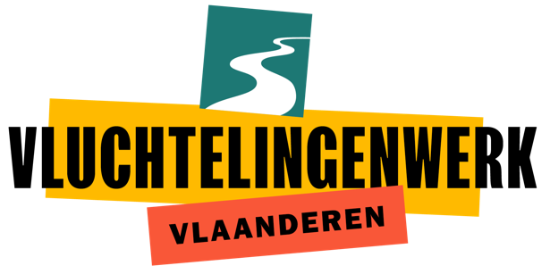
Information volunteer startpuNT

Do you want to support asylum seekers at the early stages of their path in Belgium? Become a Volunteer at our Startpunt team!

Description
The Startpunt team of Vluchtelingenwerk Vlaanderen has as its core mission providing basic information about the asylum procedure and about their rights. For years our volunteers have been present every morning at the registration center for asylum applications - the Klein Kasteeltje/ Petit Chateau in Brussels – providing information in many languages and answering to people’s questions. We are currently moving our activities to the IBZ registration center in Pacheco (Pachecolaan 44).

In addition, we inform migrants in transit in Brussels and collaborate with other local organizations. We also inform the wider public about asylum in Belgium.
We are looking for volunteers to join our team who speak English and an additional language. We give priority

The Startpunt team informs asylum seekers on the day that they register themselves in Belgium. Every morning a crew of the Startpunt team is present at the arrival centre in Brussels. They give the asylum seekers information about the asylum proceduure in Belgium and the rights that they have.

We are looking for
- Someone who speaks fluent English and an additional language. We prefer Arabic, Pastho, Tigrynian, French, Spanish, Turkish and Kurdish
- Someone who can communicate in a clear and simple way
- Someone who is eager to learn and take new challenges
- Someone who is empathetic and a good listener
- A team player, willing to listen to and support their colleagues
- Someone who has refugees’ rights and human rights at heart

tasks
- Give basic information about the asylum procedure and rights to the asylum seekers
- Answer asylum seekers’ questions concerning their asylum procedure
- Participate to the writing of a daily report
- Refer asylum seekers to other services in Brussels

We offer
- Volunteer work with social relevance in an interesting work environment
- Trainings (basic training about asylum procedure and asylum seekers’ rights + trainings on specific topics)
- Insurance for volunteers
- Reimbursement of public transport or a volunteer fee under circumstances

Apply
Applications and questions can be sent to imane@vluchtelingenwerk.be

WhAT IS VLUCHTELINGENWERK?
Vluchtelingenwerk Vlaanderen advocates for people that are fleeing war, violence and persecution. We don’t do this alone, we work together with around 30 member organisations and motivated volunteers. Together, we increase pressure on the policy and we inform the general public. We work on integration of refugees and we support everyone who supports asylum seekers and refugees.
WWW.VLUCHTELINGENWERK.BE

We recruit on the basis of competencies and talents, regardless of age, gender, origin, sexual orientation or (functional) disability. Startpunt team wants its volunteers to be a reflection of our society. We are therefore working on a balanced diversity policy. We especially encourage refugees and asylum seekers to apply.

